Sheela Ahmed

David Long

Intro to Imaging and Video Systems

Lab 7: Real Sensitometer Measurements

|  |  |  |  |
| --- | --- | --- | --- |
|  | *Red* | *Green* | *Blue* |
| *5219* | -2.69 | -2.998 | -3.106 |
| *5212* | -2.615 | -2.235 | -2.046 |
| *5217* | -2.525 | -2.296 | -2.525 |

LogE Values

Figure 1

Figure 2

**Comparing Speeds**:

Out of the three film strips, the reference 5219 film has the fastest speed compared to the 5212 and 5217 films. A lower value in stops means the film absorbs the necessary energy faster, hence a greater speed. Figure 2 shows the actual logE values corresponding with the actual density value – which is .2 units above the minimum – and compares the three film strips. Reference 5219 has the lowest logE values, according to the table, for all three channels, meaning there is less energy required for it to absorb fully. This can also be seen visually when looking at the graph. The 5219 film leaves its asymptote on the left side before the others. In other words, its asymptote has the shortest duration compared to 5212 and 5217. So the reference 5219 film requires less energy to absorb fully, whereas the 5212 film requires the most energy since it left its asymptote last, and therefore has the slowest speed.

*How to Solve:*

In order to calculate the speeds of each of the channels in each of the films, I found the actual exposure value first. This was found using the equation

actual Density – low Density = actual logE – low logE

high Density – low Density high logE – low logE

where the actual density is .2 density unites above the minimum, high density is the value above the actual, and the low and high logE values are the x values that pair with the low and high density values.

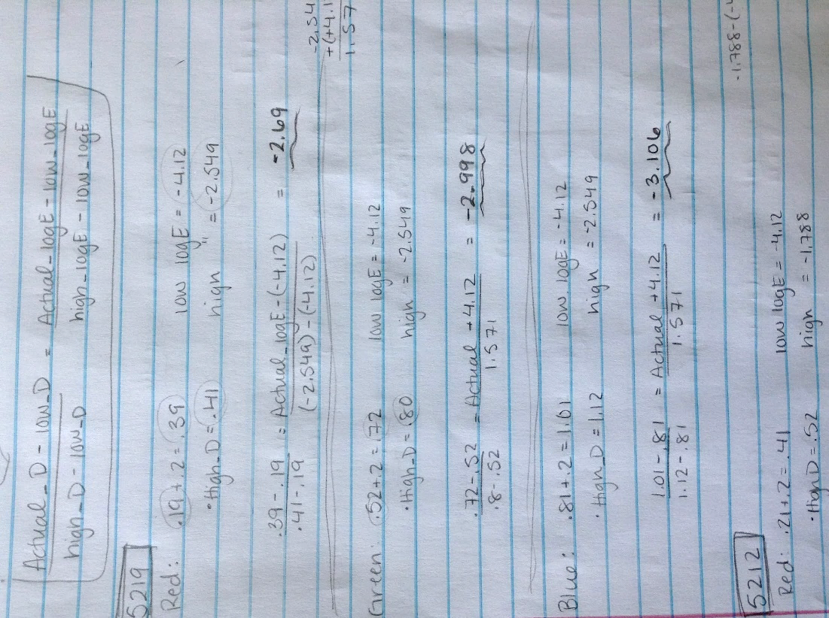For the red channel on the reference 5219 film strip, I had my actual density value as .39, which was .2 units above the lowest density value, .19. Since the value was .39, my high density value came out to be .41, and the logE values that paired were -4.12 lux-sec as the low and -2.549 lux-sec as the high. After plugging in these known values, my value for the actual logE was -2.69.

Figure 3

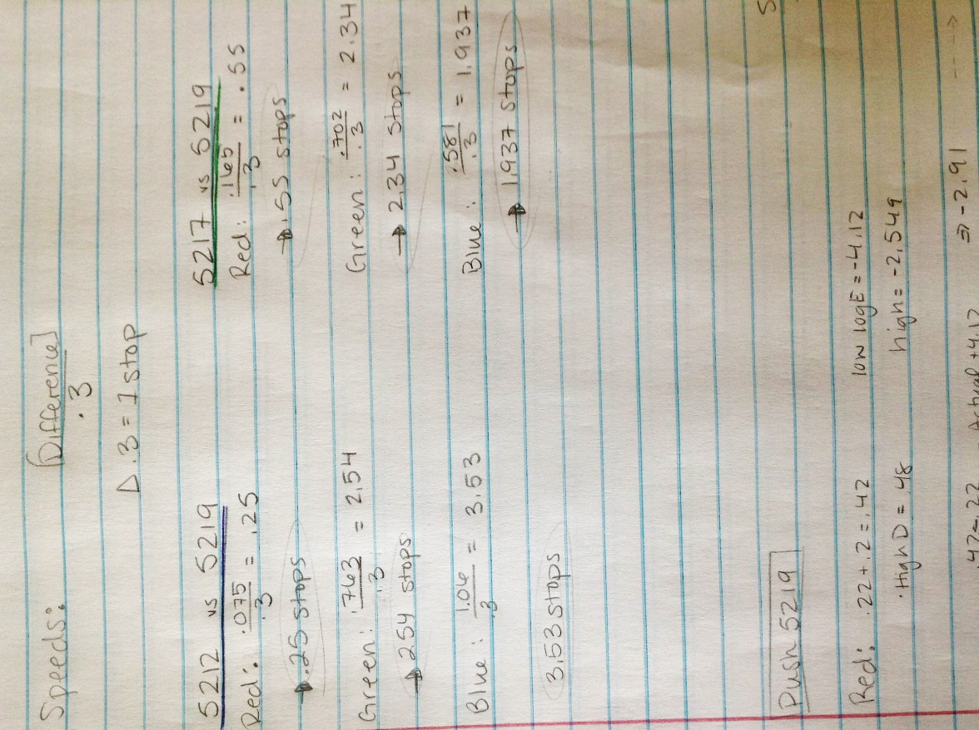I repeated these steps for the remaining channels and received values of -2.998 for the green channel and -3.106 for the blue channel. I then repeated the same steps for the 5212 and 5217 films to compare the differences and found the speed in number of photographic stops.

To calculate the speed, I took the differences in the values – comparing 5217 and 5212 to the reference 5219 – of each of the three channels and divided it by .3 (which is the value given for 1-stop increments because of the logarithmic nature of human perception). The calculations for this shown in Figure 4 indicate the differences between 5217 and reference 5219 are smaller than between 5212 and reference 5219. By looking at these results, I confirmed that 5217 had a faster speed than 5212, but couldn’t conclude if it was faster than the 5219, which is why the visual representation of the graph confirmed that the reference 5219 was actually faster than 5217, and hence the fastest out of all three.

Figure 4

**Comparing Contrast**

|  |  |  |  |
| --- | --- | --- | --- |
|  | *Red* | *Green* | *Blue* |
| *5219* | .50 | .58 | .56 |
| *5229* | .41 | .45 | .42 |

Contrast Values

Figure 5

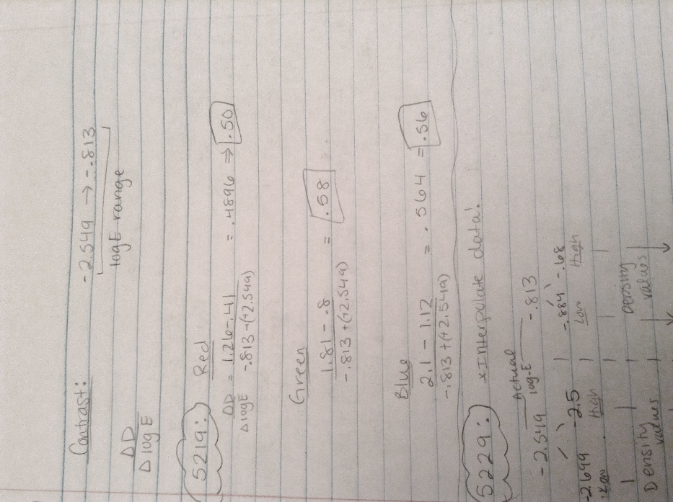*How to Solve:*

Since the x-range values for the 5229 and 5219 film strips were different, the values for 5229 needed to first be interpolated to match exposure values with reference 5219. The first step to interpolating the data was to find a range of exposure values that was within the asymptotes of every curve on the graph. In this case, the range was from -2.549 to -.813. The contrast equation is simply the change in density divided by the change in exposure (ΔD/ΔlogE). So for the reference 5219 film strip, the contrast was fairly easy to find because all the values were given. The difference in exposure was -.813-(-2.549) = 1.736. The density values paired with the exposure values, so after plugging the numbers in, the contrast values for all three channels came to be around .5, as is shown in Figure 6.

Figure 6

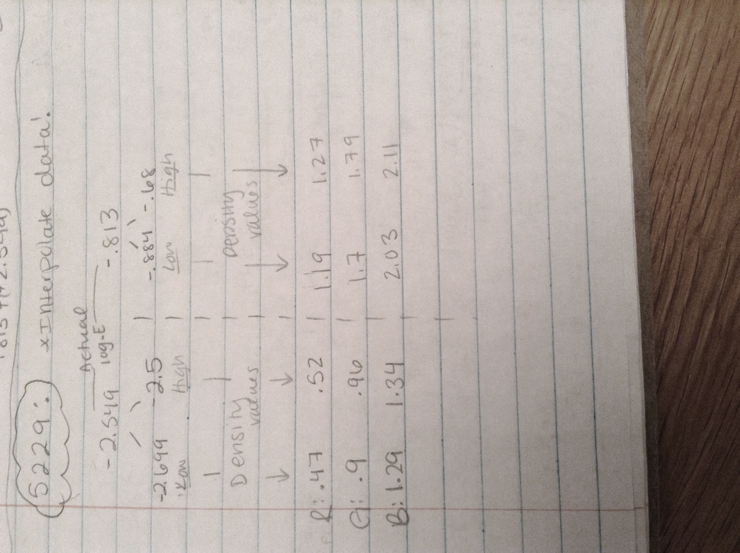 The primary goal for interpolating the data of the 5229 film strip was to find actual density values to plug into the equation for contrast, given the actual exposure values -2.549 and -.813, by using the equation used earlier to calculate speed. First, I found the logE values that surrounded -2.549 and -.813, and then determined the density values for all three channels at those high and low exposure points (shown in Figure 7). I then used the same equation used earlier, but instead solved for “actual density”. The values are shown in Figure 8. Using these density values, I then plugged them into the equation to find contrast, measuring the change in density over the change in logE, and received answers of .41 for red, .45 for green and .42 for blue.

Figure 7

*Analysis:*

These values were less than the reference 5219 film strip since they were around .4 rather than .5, which indicates the 5229 film strip has a lower overall contrast on the images. Since contrast is ΔD/ΔlogE, it is the slope of the curves on the graph, and without the asymptotes, the curves imitate linear lines. Therefore, a larger value for slope indicates a higher contrast value so the 5229 film strip generates images with higher overall contrast than reference 5219. So if the reference 5219 film is used, there will be a higher contrast on the images rendered, whereas if the 5229 film were used, there would be a lower contrast.

**Push-1 Processing (5219 vs push-1 5219)**

|  |  |  |  |
| --- | --- | --- | --- |
|  | Red | Green | Blue |
| -2.549 | .51 | .95 | 1.33 |
| -.813 | 1.22 | 1.73 | 2.06 |

Using the same equation and method used for the first part, I calculated the actual logE values for the Push-1 5219 film and then compared it to the reference 5219. Visually, the differences in values aren’t substantial, so the stop values for each of the three channels came out to be around or less than 1, meaning there was less than a 1-stop difference between reference 5219 and push-1 5219. It was expected that the speed would be much greater after push-processing, which indicates that push-1 doesn’t function as it’s advertised.

The push-1 5219 film strip advertises that since it has a faster photographic speed, a cinematographer can underexpose their set and not worry about any problems later on, but if the photographic speed isn’t substantially better than the reference, then underexposure on set will lead to underexposure of images during processing. However, the curves for the push-1 are slightly steeper than the reference, indicating a higher contrast which can mask the underexposure of the film. So the push-1 processing increases luminance range but doesn’t run at a much faster speed than the reference.

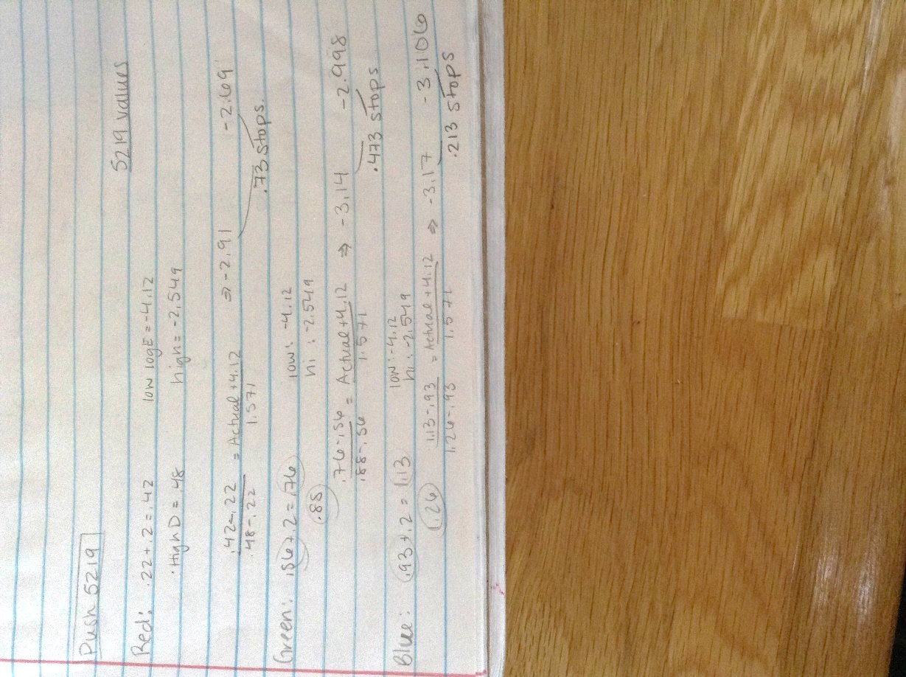[Images of all the calculations made for the lab.]

This image in the work for calculating the speed in photographic stops of the push-1 film compared to reference 5219.

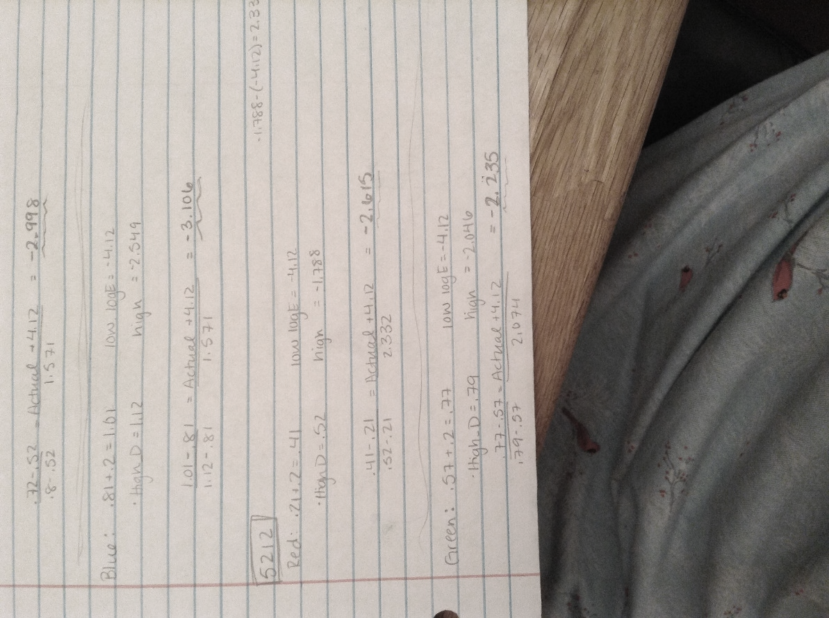

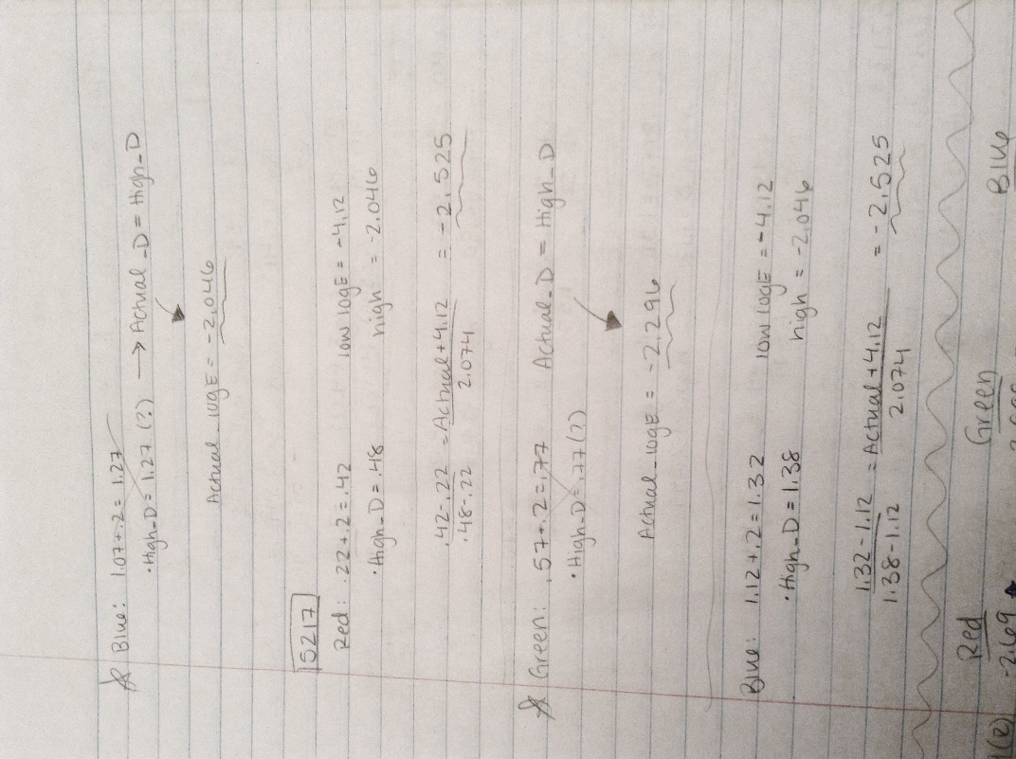

These two images show the rest of my work for calculating the speeds in terms of photographic stops of reference 5219, 5212 and 5217.